**Submission Documents List:**

1. Functional Deliverables:

♣ Screenshots or screen recordings showcasing: ♣

The product listing page with dynamic data.

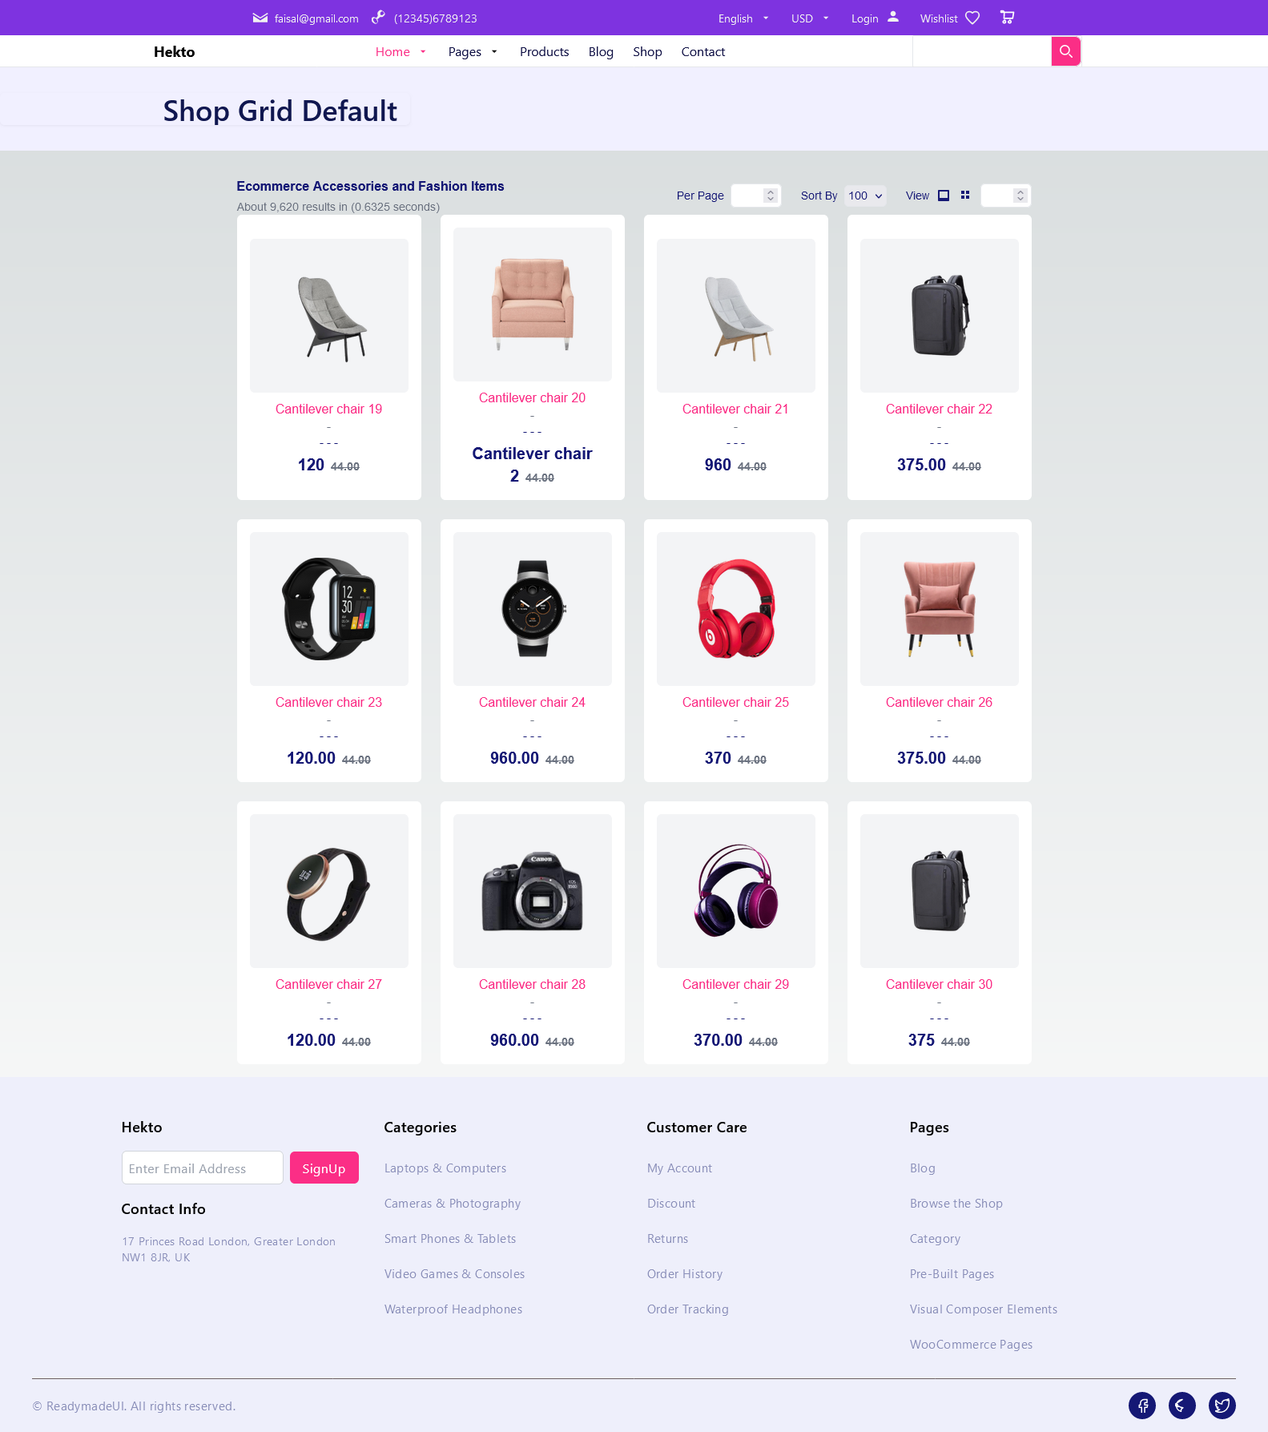

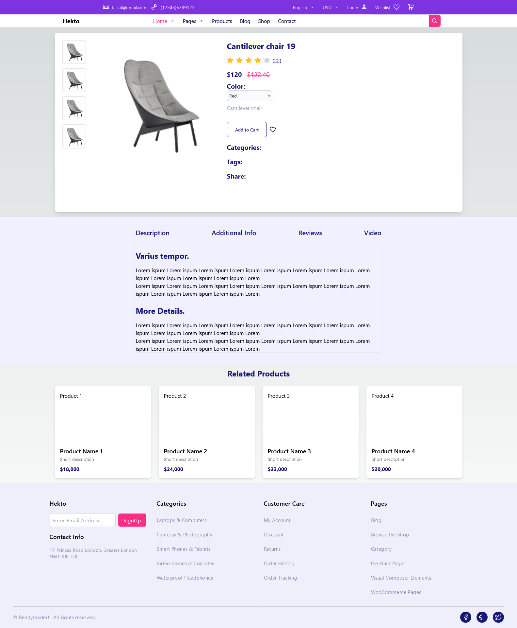Individual product detail pages with accurate routing and data rendering.

♣ Working category filters, search bar, and pagination.

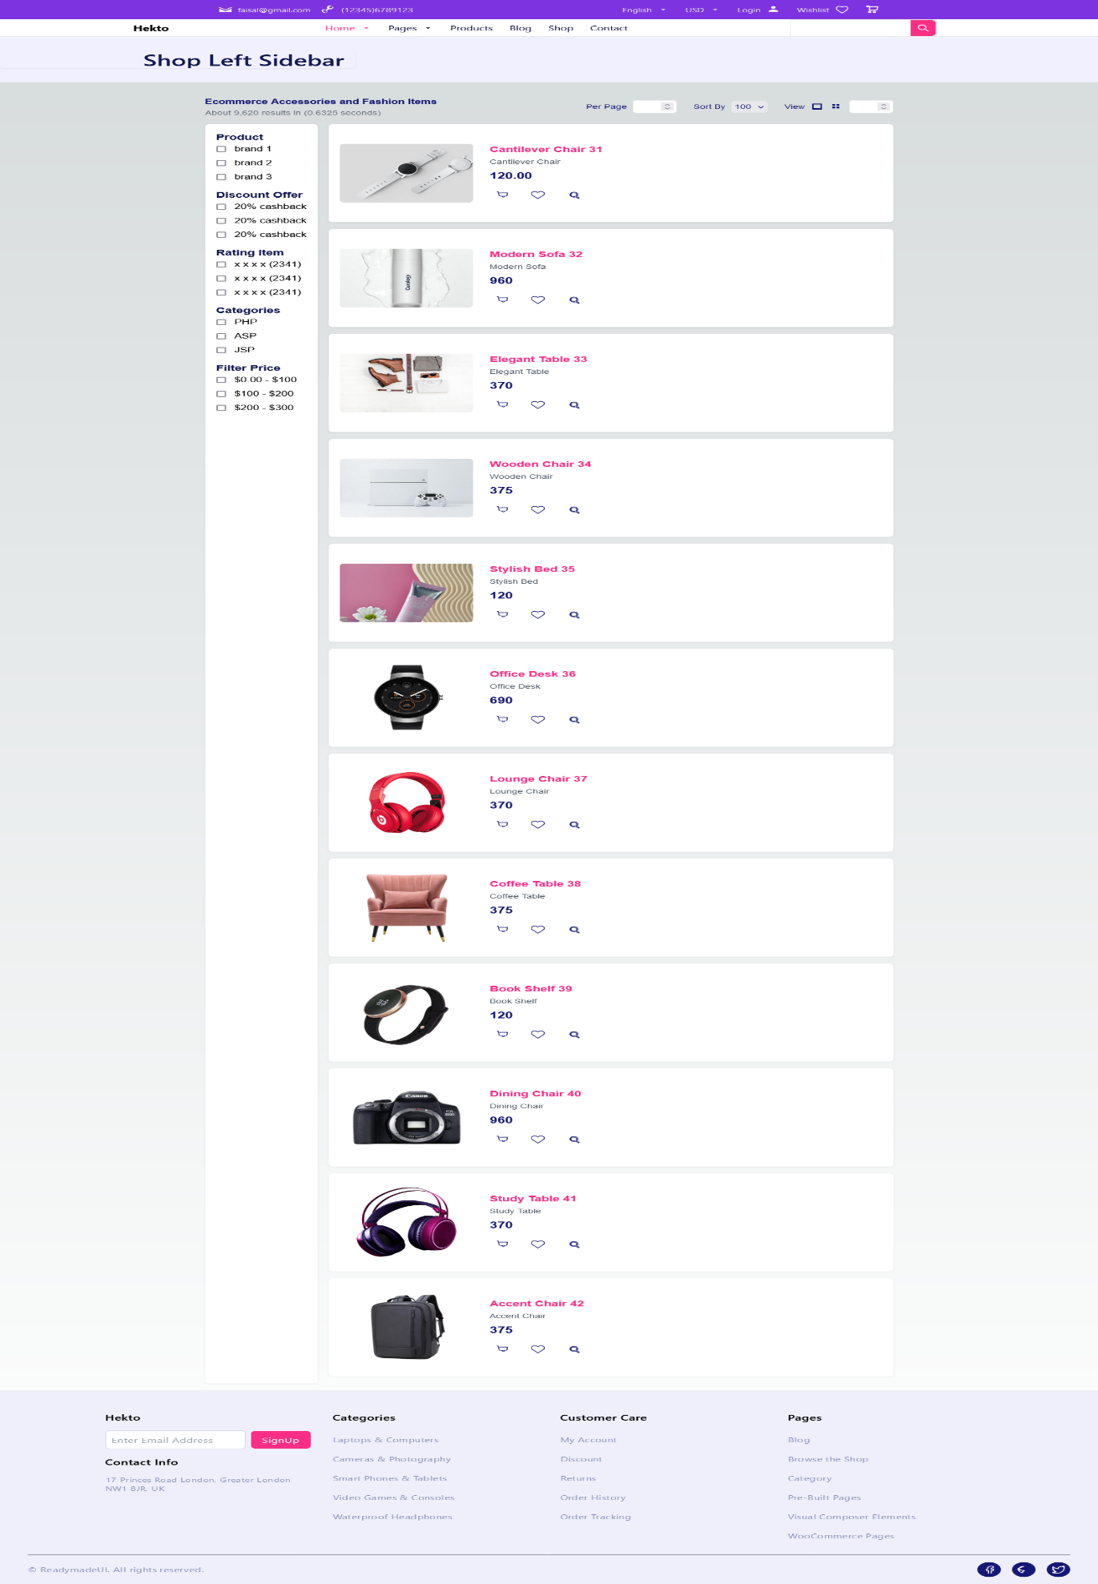

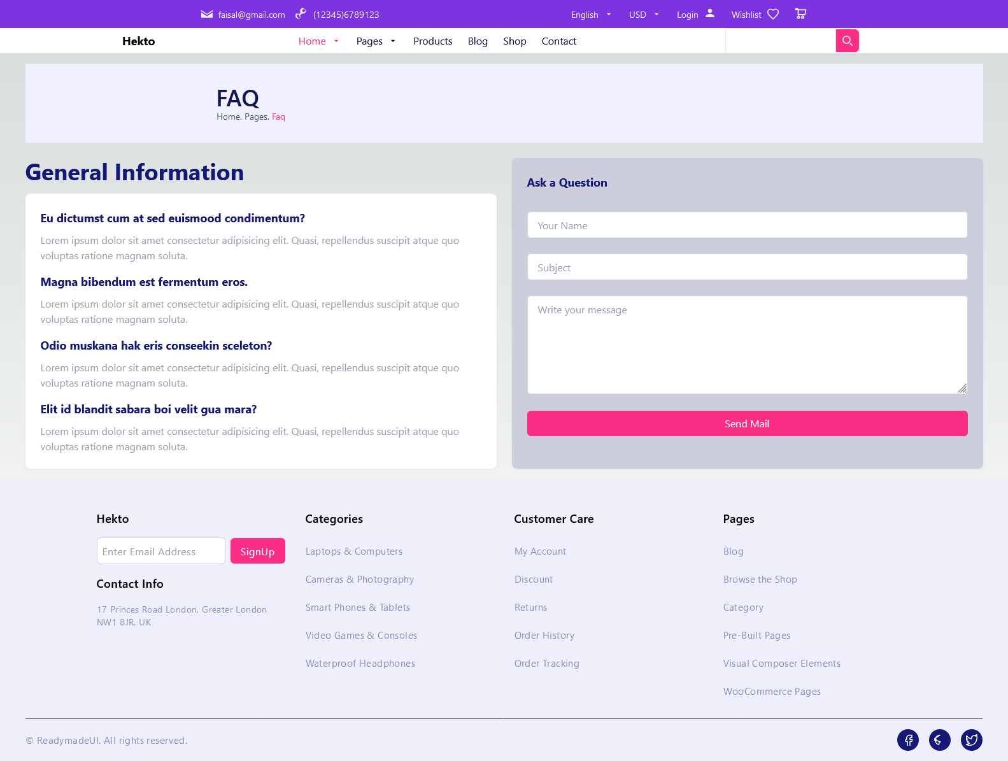Any additional features implemented, such as related products or user profile components.

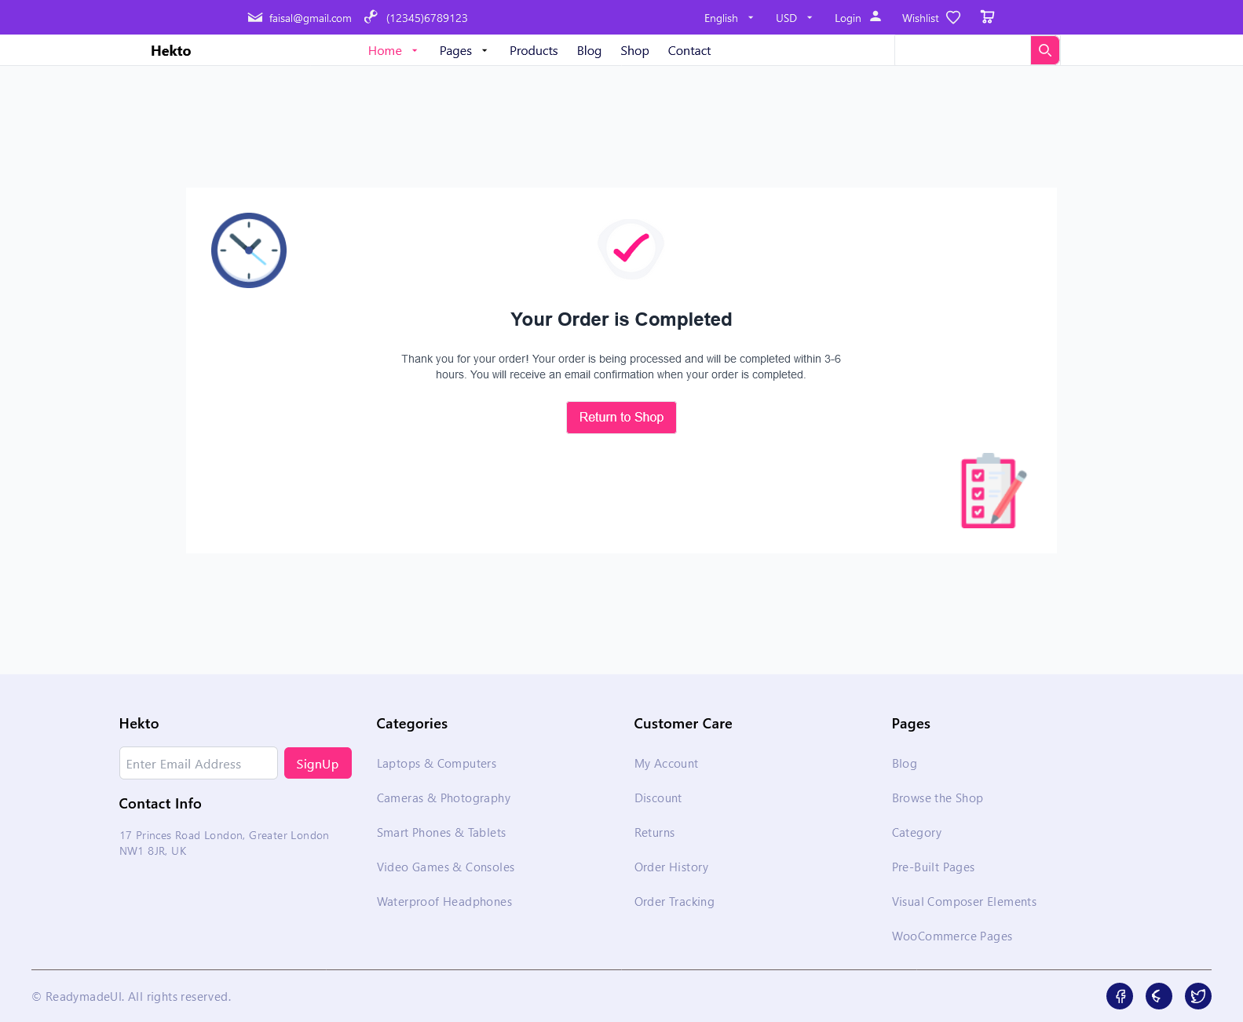

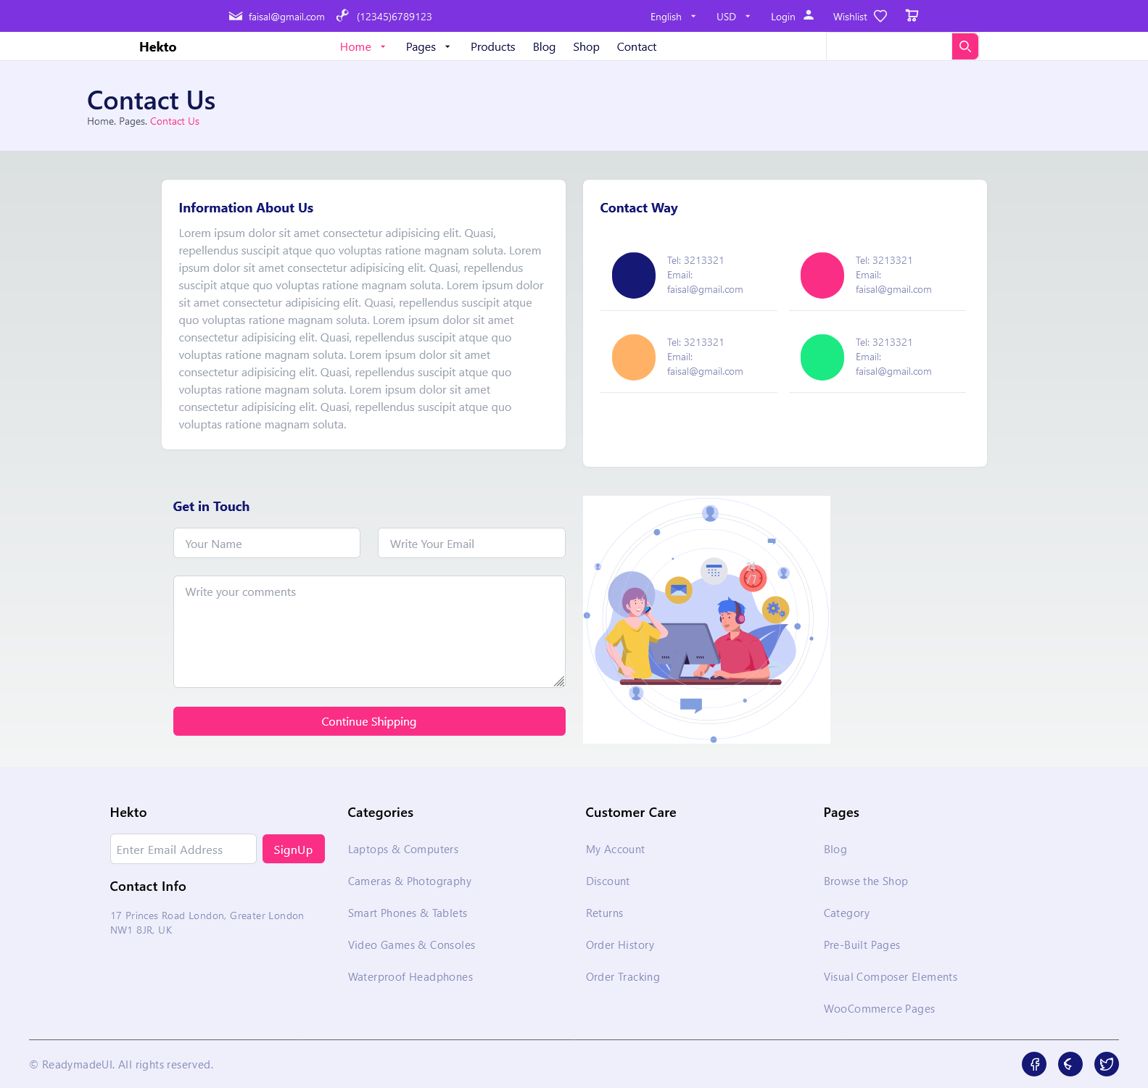



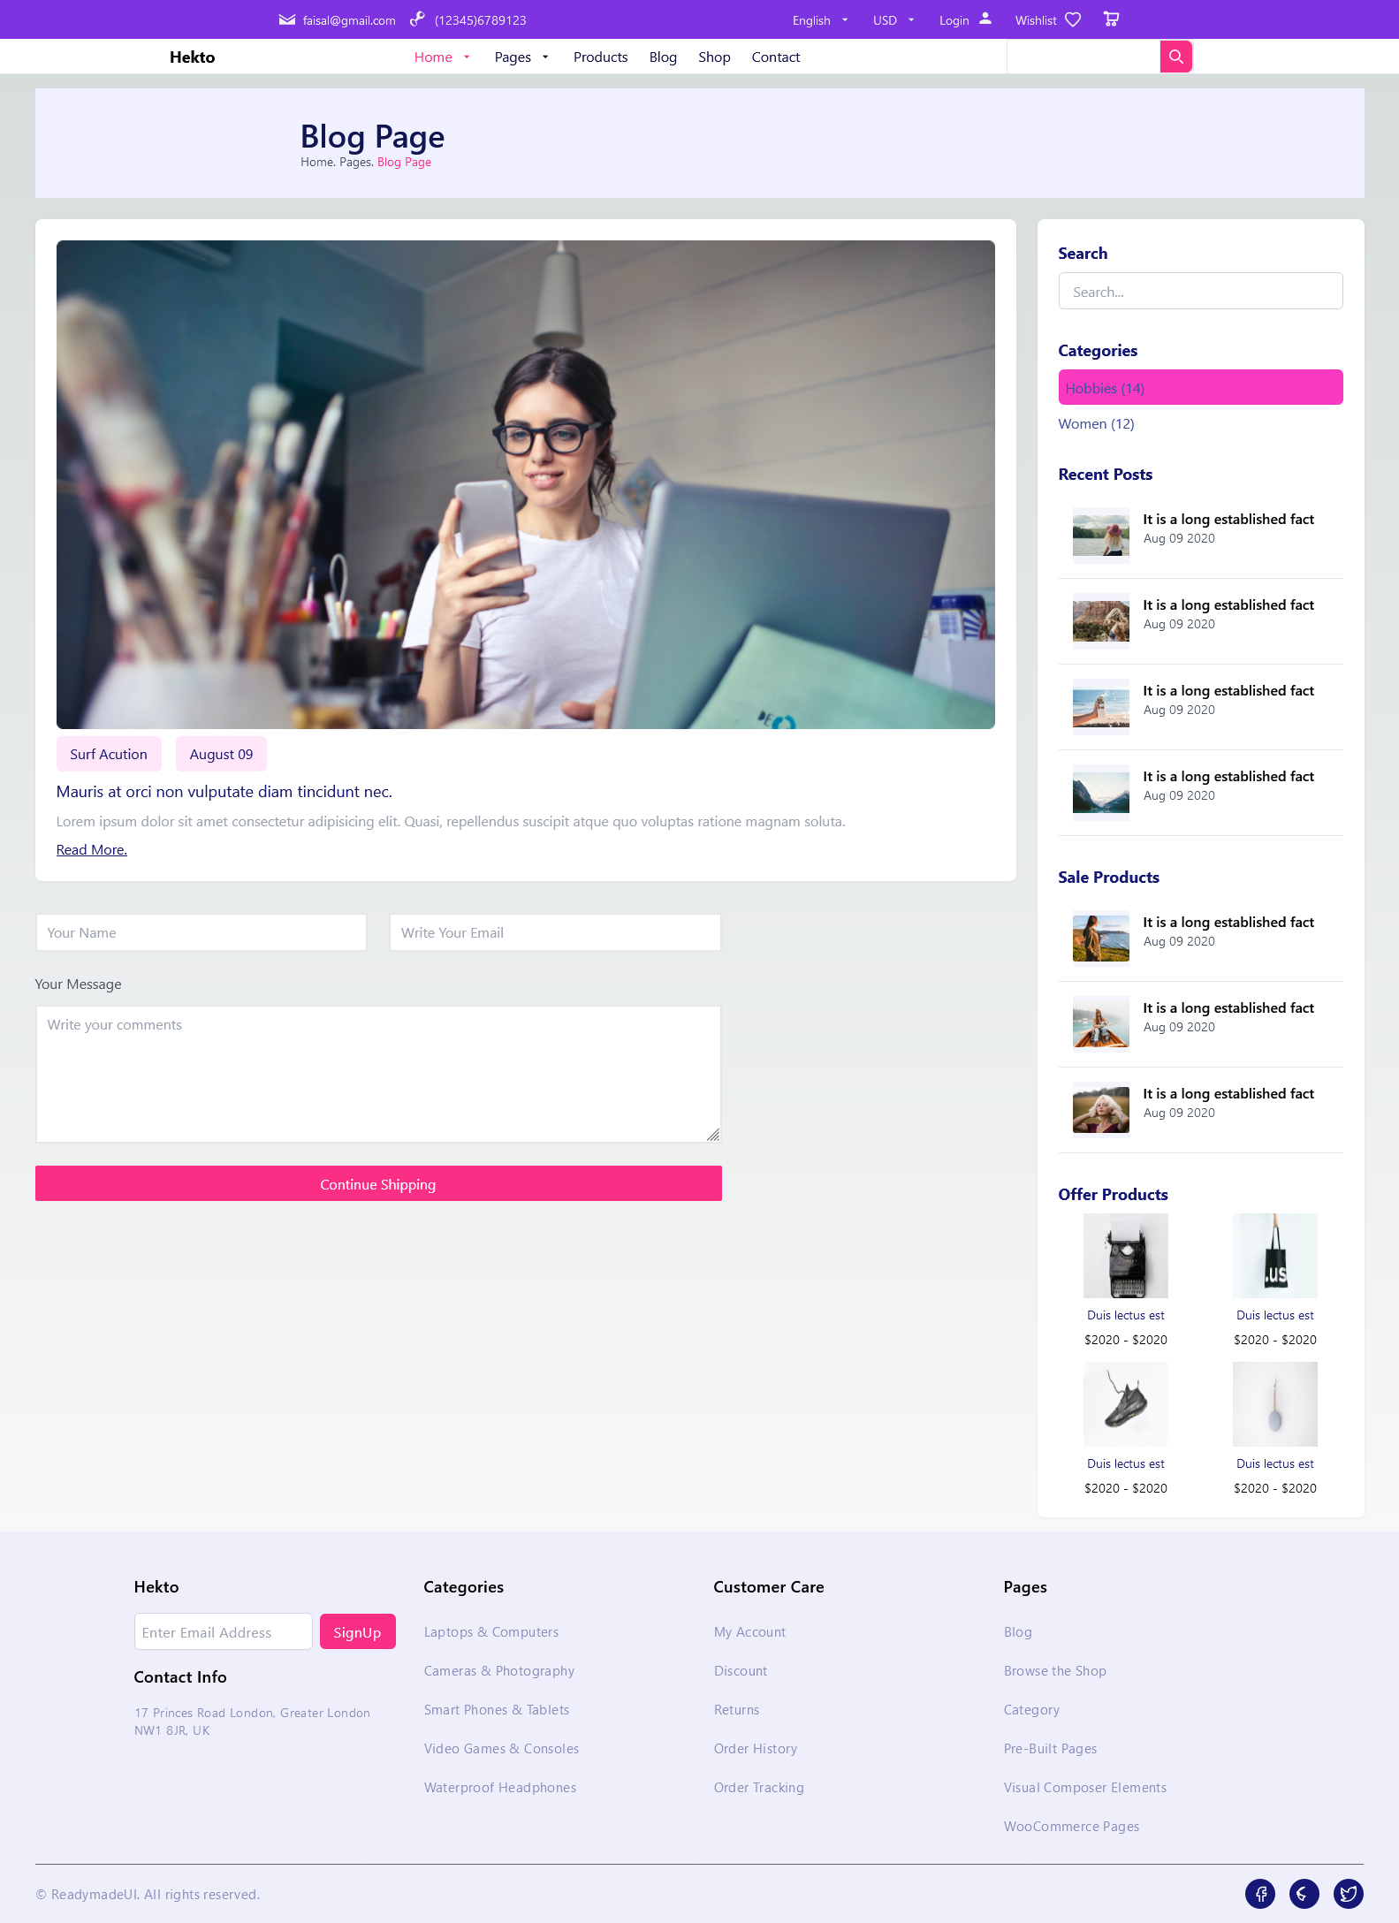

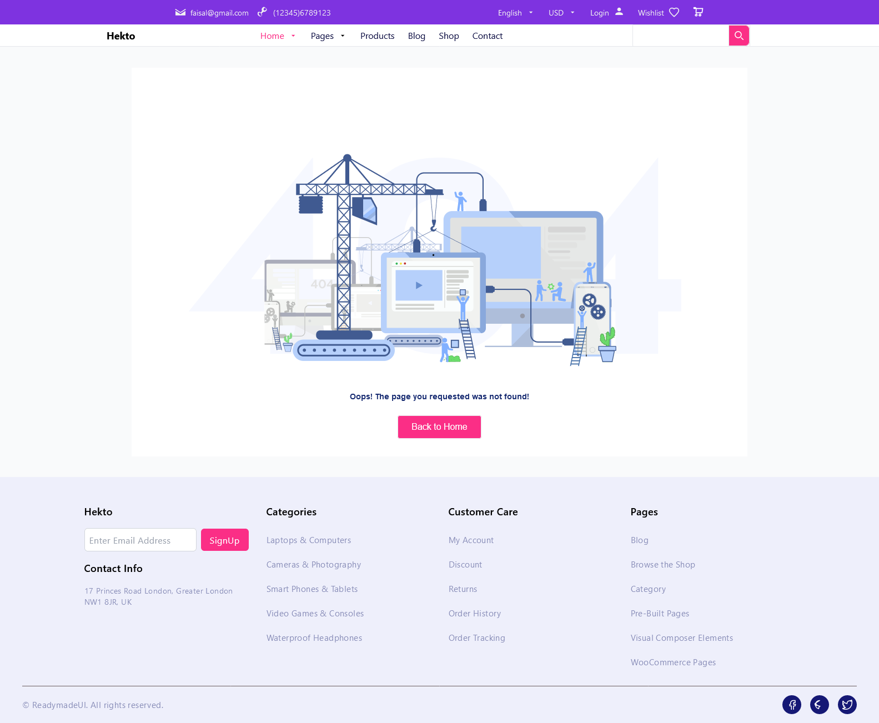

1. Code Deliverables:

Code snippets for key components (e.g., ProductCard, ProductList, SearchBar).

Product Detail Code:

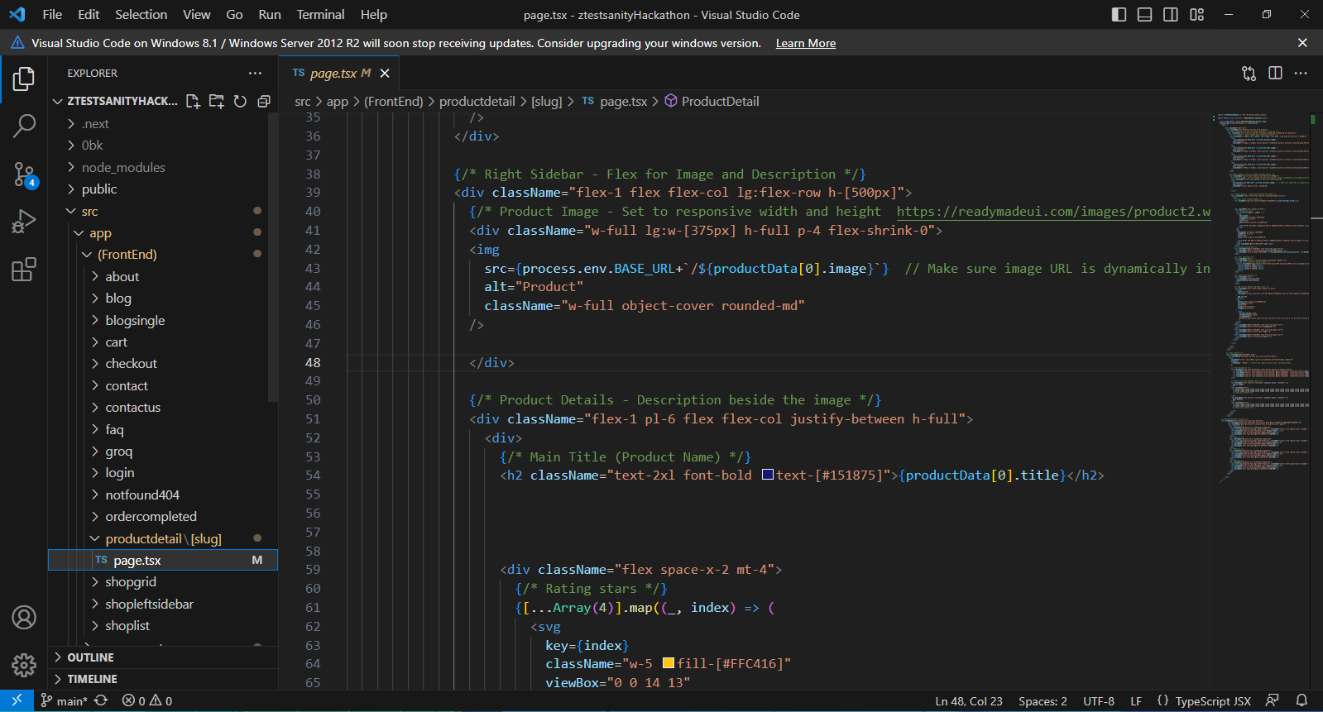

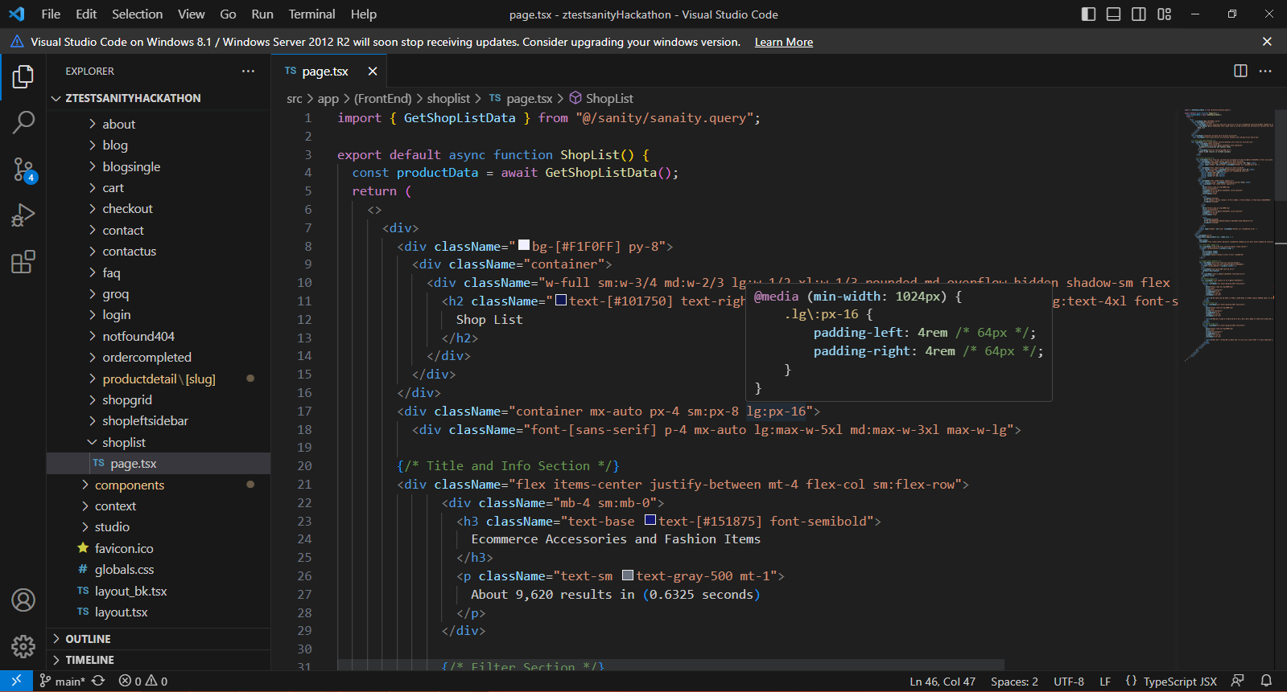Product Listing Code

Product Card:

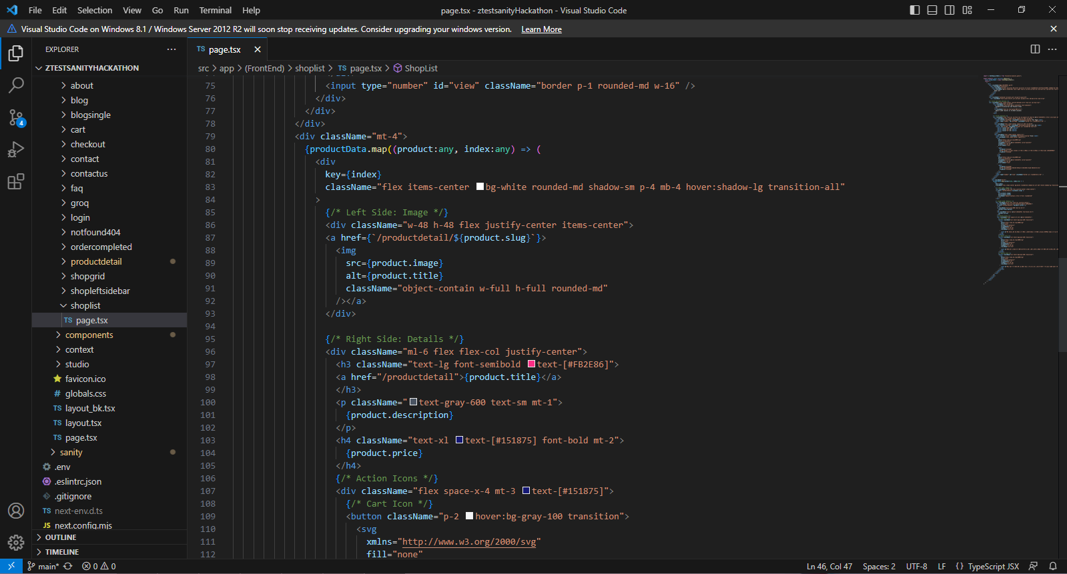

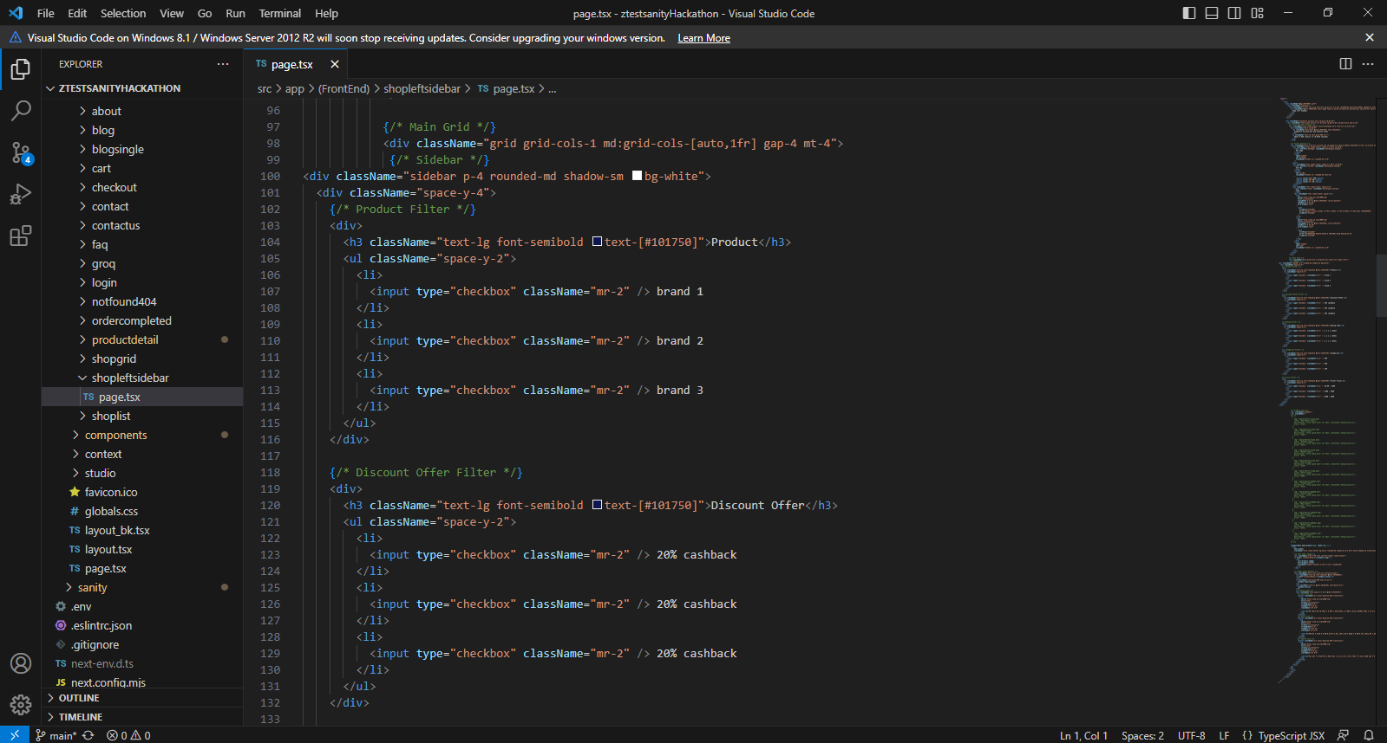 Product Filter Sidebar

Scripts or logic for API integration and dynamic routing.

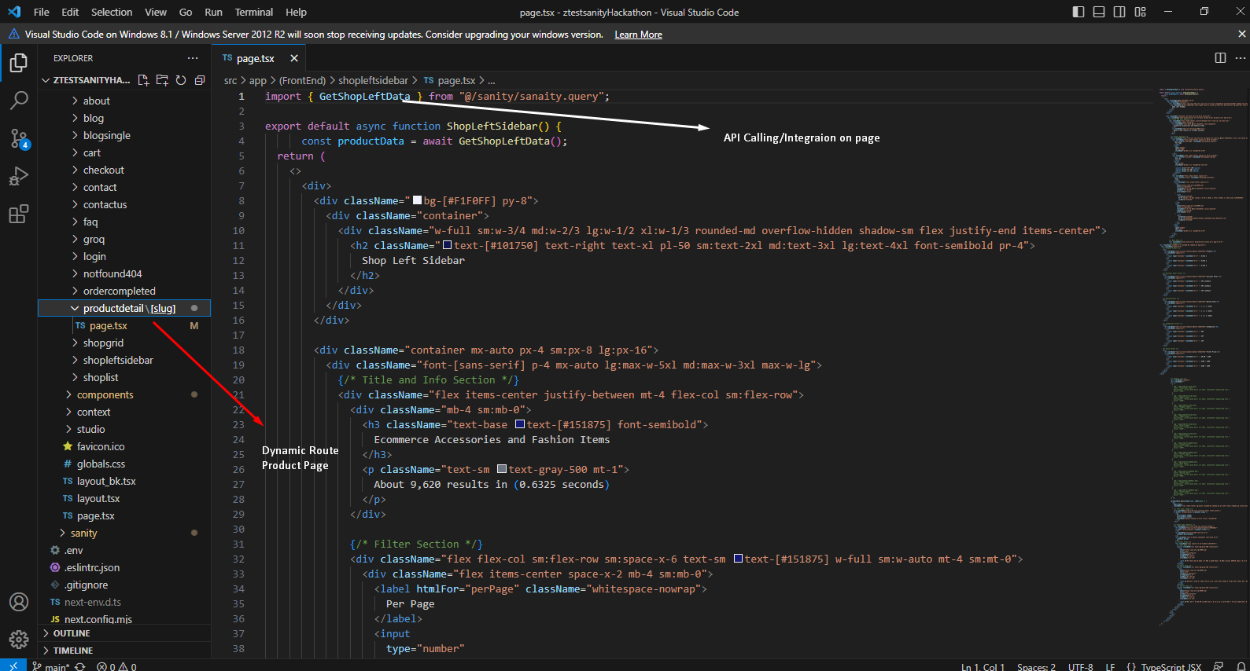

1. Documentation:

Technical Report: Development and Integration of Components

In this project, I used Next.js 14 to build and integrate reusable components that would be called across different pages of the application. The process began by creating individual components within the components folder, which allowed for better organization and reusability throughout the project. Each component was created using the export default syntax to ensure that it could be easily imported and utilized on the relevant pages. When calling a component on a specific page, I used the import statement along with the correct path to the component file, ensuring that the code was properly structured and readable.

One of the challenges I faced during development was related to correctly referencing the path of the components when importing them into various pages. Initially, there were issues with relative paths, which caused errors in loading the components. However, I resolved this issue by carefully reviewing the folder structure and correcting the import paths, ensuring that each component was properly linked to its respective page. This challenge helped me gain a deeper understanding of the importance of maintaining a clear and logical file structure within the project.

Throughout the development process, I followed several best practices to ensure the quality and maintainability of the code. One of the key practices was adhering to a consistent naming convention for both component files and folder structures. This not only made the code easier to navigate but also ensured that components were easily identifiable and could be scaled in the future. By organizing components in dedicated folders and using clear, descriptive names, I was able to create a clean and efficient development environment that facilitated smooth integration of components into various pages.

In conclusion, by following best practices for folder organization, naming conventions, and component structure, I was able to build and integrate reusable components effectively in Next.js. Despite facing challenges with path references, I successfully resolved them, and the process ultimately enhanced the overall structure and maintainability of the application.

This summary provides a clear and concise report of the steps, challenges, and best practices followed during the development.

1. Repository Submission: submitted on “Documents” folder on GitHub Repo.
2. Checklist for Day 4:

Self-Validation Checklist:

Frontend Component Development: ✔

Styling and Responsiveness: ✔

Code Quality: ✔

Documentation and Submission: ✔

========================= x x x x x x =========================